Smart Cities: A Boon or a Bane

Saransh Chopra  
20312915047

*“Smart cities do not mean creating jungles of concretes or sophisticated cities of glasses with HiFi technologies. But a smart city means a city, where humans, trees, birds, and other animals can grow with all their glories, imperfections, freedom, and creativity”*

* Amit Ray

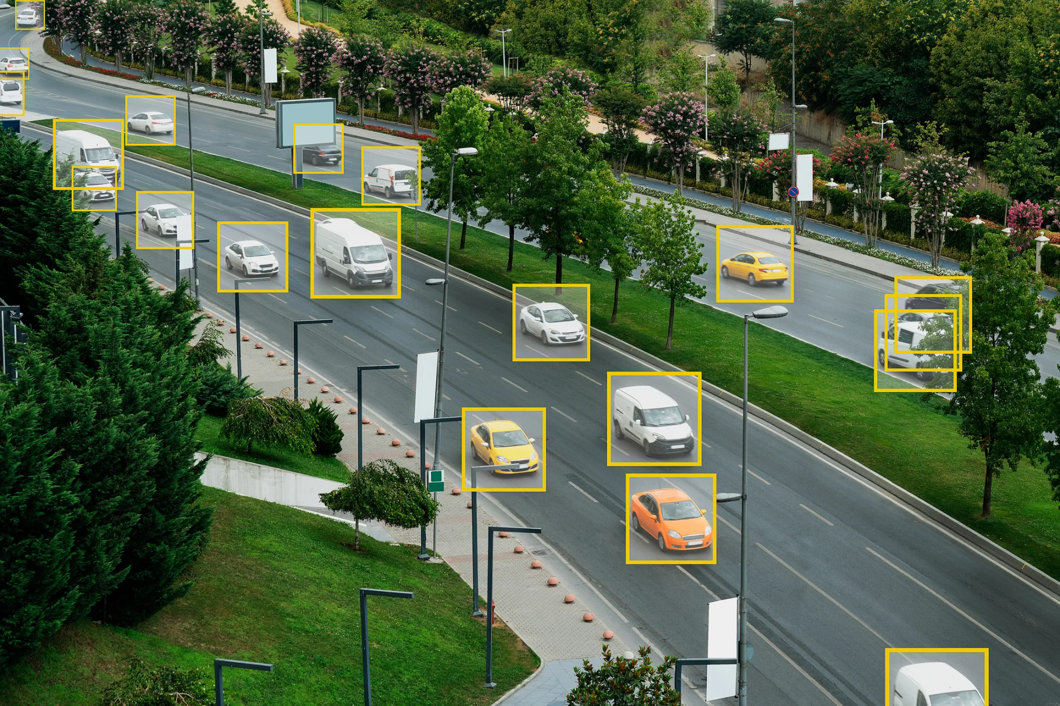

Figure 1: Monitoring traffic in real-time in Smart Cities [15].

Smart cities, powered by lots of real-time data and clever computer programs, are popping up all over the world. These cities promise to make people's lives better in the future. However, as cities change and grow, the idea of smart cities has stirred up a big debate. Some people are excited about the possibilities for a better future, while others worry that smart cities might bring more problems than solutions. In this study, I discuss if smart cities are as good as they seem or if they could cause issues. Specifically, I'll look into whether smart cities can truly make things more efficient, and sustainable, and improve our lives, or if they might invade our privacy, make social inequalities worse, and use technology in ways that do more harm than good. This article will also focus on China, a country that's really into the idea of smart cities, as a case study to see what's happening now and what we can expect in the future.

A Smart City is a tech-savvy neighborhood where technology does the heavy lifting in daily tasks. This urban area relies on advanced gadgets and computers to make life easier by analyzing a massive amount of real-time data. This data comes from people, businesses, government agencies, and non-profits, collected through 24/7 surveillance cameras, sensors, and other electronic methods. The goal is to automate tasks that usually need people's involvement, like managing traffic lights or keeping track of the spread of diseases such as COVID-19. According to the Indian Government, a smart city aims to create economic opportunities and jobs for a wide range of residents, no matter their education, skills, or income.

However, there's a missing piece in many definitions of smart cities. While these cities sound promising, they often don't emphasize the need for personal and private data to make them work. Think of it like your computer needing your login details to show your personalized stuff. Similarly, smart cities need personal data to turn their high-tech ideas into reality. This raises important questions about privacy and how much personal information we should share for the greater good. So, while smart cities bring exciting possibilities, we must also consider how to keep our details safe and secure.

# Formal definitions of a Smart City

A smart city is a technology-driven urban area built to automate menial tasks by identifying patterns through the data collected on a massive scale in real-time. This data can originate from citizens, corporations, governing bodies, or non-profit organizations. The data is collected using 24/7 surveillance cameras, sensors, and other electronic methods. This data is then utilized to automate tasks that other cities require human interference, such as traffic light systems or even COVID-19 spread oversight. According to the Indian Government - "Smart city offers sustainability in terms of economic activities and employment opportunities to a wide section of its residents, regardless of their level of education, skills or income levels." More precisely, four factors create a smart city:

* Applying a wide range of electronic and digital technologies to communities and cities.
* The use of ICT to transform life and working environments within the region.
* The embedding of such Information and Communications Technologies in government systems.
* The territorialization of practices brings ICT and people together to enhance the innovation and knowledge that they offer.

However, most definitions do not capture the essence of personal and anonymous data required to bring the concept of a Smart City from an ideation phase to reality.

# China's booming Smart City Economy

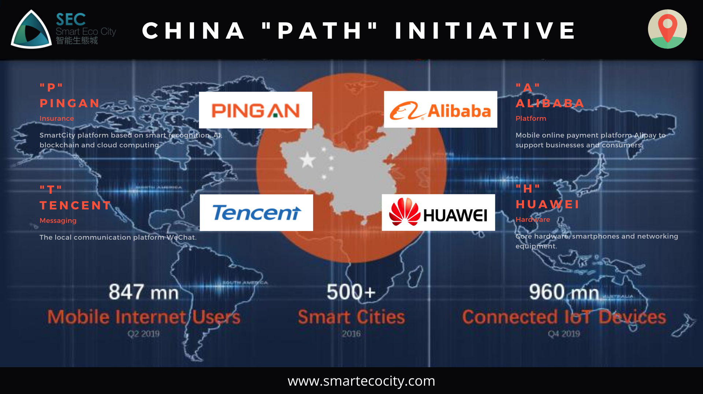  
Figure 2: Key stakeholders in China’s Smart City initiatives [3].

Smart cities, often outsourced to technology companies, promise to make our urban environments more livable, keep the traffic flowing, save energy, and even help keep us safe. Countries all across the world are embracing smart cities, but there is one country on top of the Smart City radar: China. In fact, most countries planning to build smart cities are outsourcing their business to Chinese technology companies.

## Shenzhen



Figure 3: Shenzhen smart city [11].

Examining Shenzhen, China's Silicon Valley and the third most populous city in the country, reveals a notable integration of advanced technologies. Shenzhen has earned its name as China's Silicon Valley due to its vibrant tech and software development scene. It is the birthplace of major tech giants such as Huawei and Tencent. Leveraging this technological foundation, Shenzhen has successfully implemented artificial intelligence and big data technologies across diverse sectors, including transportation, healthcare, and social security. For example, Shenzhen has dynamic traffic light management aligned with real-time traffic conditions and cloud-based data facilitating expedited diagnosis of COVID-19 cases in healthcare settings. The resultant digital infrastructure identifies strategic sectors for focused development and optimizes resource allocation based on critical needs. This has created substantial cost savings for governmental bodies and enterprises, potentially amounting to billions annually.

## Ping An Smart City

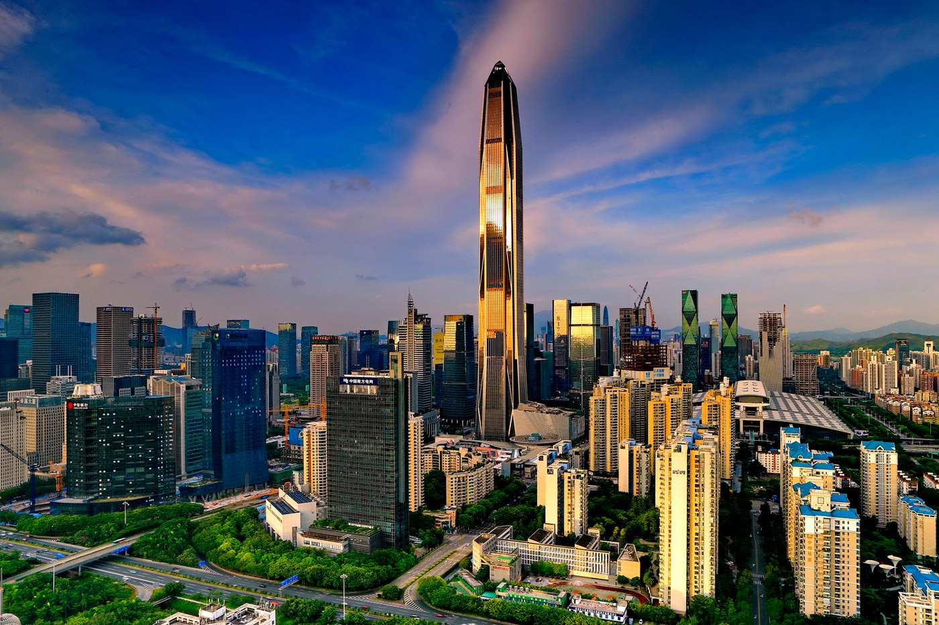

Figure 4: Ping An Smart City [14].

Taking another example, the Ping An Smart City has used technology provided by Chinese tech giants like Alibaba and Tencent to create a novel way to interact with the government. The iShenzhen mobile app manages 8,000+ government affairs, from bills to benefits. The Smart City has also transformed the government's food regulation network. The approval period has decreased from a few weeks to a few hours, given that the process has now been automated using cameras and sensors. The sensors can even catch a mouse running on the hotel's kitchen floor and make the government's final decision. The timing of intelligent traffic lights is adjusted to improve flow efficiently. Surveillance cameras can capture traffic violations, which happen in real-time at a blazing fast speed, thanks to 5G. The city also saves the government billions of dollars after the initial investment. Still, researchers outside China are skeptical about the degree of usage of the data collected by the cameras and sensors.

## Government’s role in promoting smart cities

Apart from the top 10 smart cities in China, the country also hosts over 1,000 innovative city projects globally, with the majority benefiting from the rapid implementation of 5G technology. This high-speed connectivity facilitates instantaneous communication among sensors, devices, and databases. The success of smart cities in China is also owed to government policies. The concept of smart cities is favored by Xi Jinping publically, and smart cities are, in fact, uplifting China's economy. The notion has become the country's strategy to migrate people from rural to urban areas. China's urban areas are expanding at a rapid rate; every year, 20 new cities are built from scratch in China. Even after such efforts, China is behind the West regarding urbanization, where smart cities come into action. This strategy has also proved to be a way to sustain the country's already high productivity levels. The Communist Party's latest five-year plan promises to roll out five interconnected Smart City clusters connected via high-tech infrastructure.

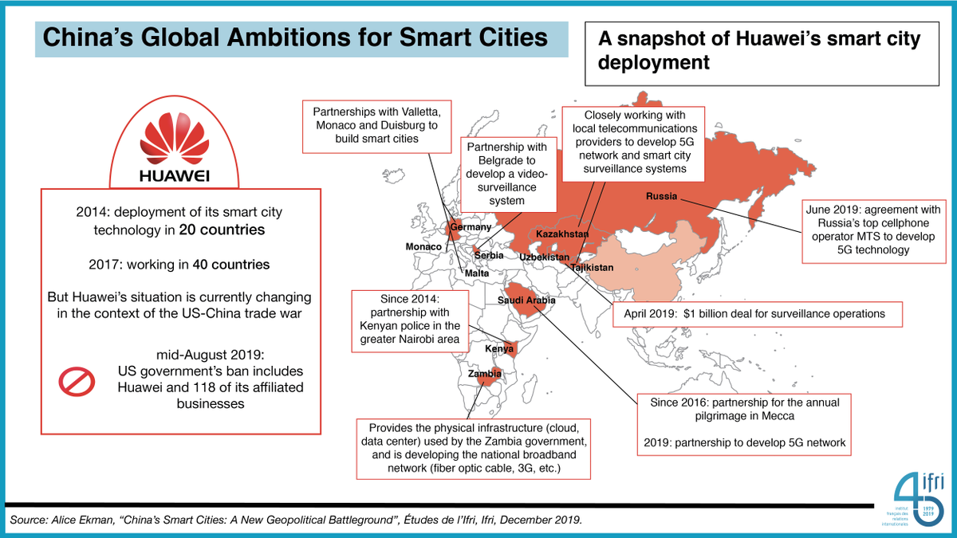  
Figure 5: China’s global ambition for smart cities [4].

## What are critics saying about China's Smart Cities

Even though China is making amazing progress in smart cities with advanced technology, some folks are concerned about the possibility of too much surveillance. The use of cameras and sensors to watch people for traffic control, prevent crime, and save energy has made people talk about privacy. Chinese researchers explain that despite focusing on cameras, less than 40 percent of smart city devices are actually cameras. Most are data sensors that collect info about things like air quality and noise levels, challenging what we usually think of as smart city tech.

However, it's true that the Chinese government now has a more effective way to keep an eye on citizens in real-time. According to China's Cyber Security Law, companies must store users' data on local servers and decrypt it if the authorities ask. Huawei, a company from China's Silicon Valley, Shenzhen, led the shift to this technology and introduced 5G in China. But the European Union and the U.S. are worried about Huawei's role in 5G networks. The U.K. plans to remove Huawei tech from its 5G networks by 2027, mentioning security reasons.

So, while smart cities want to make life more convenient, there's concern about how much privacy people might be losing. Using advanced tech raises questions about finding the right balance between efficiency and protecting people's personal info. The debate about Huawei shows that different countries have different opinions about the risks and benefits of these new technologies. It reminds us that as we welcome innovation, we need to carefully think about the possible outcomes and make sure technology helps everyone without giving up important values like privacy and security.

# India’s Smart City Mission

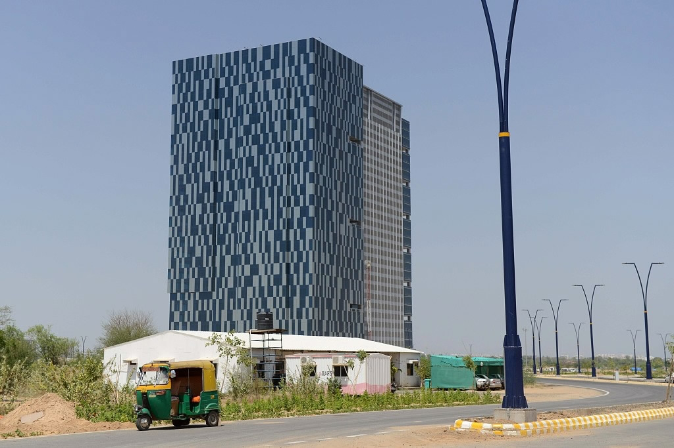

Figure 6: Buildings and solar panels, part of the Gujarat International Finance Tec-City (GIFT City), India's first "Smart City." [12]

The Smart City Mission, initiated by the Bharatiya Janata Party (BJP) government under Prime Minister Narendra Modi, aims to transform urban areas in India into smart cities. The project, launched in June 2015, has set the ambitious goal of developing at least 100 cities with modern infrastructure and amenities by 2022. These smart cities are envisioned to have advanced public transport systems, high-quality healthcare services, modern educational facilities, and widespread WiFi connectivity.

The Smart City Mission reflects a vision for urban modernization, with a focus on creating sustainable, technologically advanced, and livable urban spaces across the country. The initiative seeks to use technology to improve the quality of life for citizens, enhance economic growth, and promote sustainable development. The Smart City Mission has already led to the development of several innovative projects, such as the installation of smart streetlights, the creation of intelligent traffic management systems, and the implementation of smart waste management solutions. The Smart City Mission has also created opportunities for public-private partnerships, with private companies collaborating with the government to develop and implement smart city projects. This has led to the creation of new jobs and economic opportunities, contributing to the overall growth of the country.

Overall, the Smart City Mission is a significant step towards creating a more modern, efficient, and sustainable urban landscape in India. The initiative has the potential to transform the lives of millions of citizens, making cities more livable and enhancing economic growth.

## Expansion rate of Indian Smart Cities

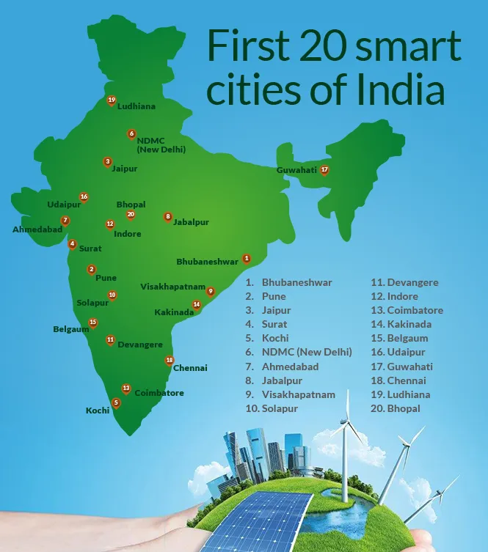

Figure 7: First 20 smart cities of India [13].

India's Smart City Mission, which aims to transform urban areas into modern, technologically advanced, and sustainable smart cities, has been criticized for progressing slowly. By June 2017, only 60 cities had been selected for the project, and work had just begun in some of them. This slow progress has raised concerns about the timely implementation of the initiative.

The criticism stems from the fact that the Smart City Mission, launched in 2015, had set the ambitious goal of developing at least 100 cities with world-class infrastructure and amenities by 2022. However, the pace of selection and implementation has been slower than anticipated, leading to questions about the effectiveness of the project.

The government has acknowledged the need for expeditious implementation of the Smart City Mission and has expressed its commitment to the project's success. Efforts are being made to address the bottlenecks and accelerate the progress of the initiative to ensure that the vision of creating smart cities across India becomes a reality.

## Comparing Indian Smart Cities to Chinese Smart Cities

China has made significant strides in building smart cities, with a particular example being Shenzhen. Shenzhen's transformation from a small fishing village to a bustling metropolis showcases China's success in urban development. The city's rapid growth and economic prosperity have been attributed to its vibrant economy, fueled by rapid foreign investment and its status as China's first Special Economic Zone (SEZ) in 1980. Shenzhen's success has been linked to its farsighted spending, greater administrative autonomy, and a focus on sustainable development.

While India's Smart City Mission reflects a vision for urban modernization, the comparison with China's smart city development highlights the need for India to accelerate its efforts and learn from successful models like Shenzhen. Embracing lessons from China's experiences, such as integrating resettlement plans with regional socioeconomic development and fostering cooperation between IT companies and the government, could potentially guide India's smart city initiatives towards greater success.

## Learning from Chinese smart cities

India can learn several lessons from China's successful smart city development. One key lesson is the importance of integrating resettlement plans with regional socioeconomic development. This means ensuring that those who are displaced due to the creation of new smart cities are provided with sufficient compensation, training in new skills needed in the new economy, and new opportunities. This can help prevent stalled projects and ensure that those who have lost their land are provided with the economic skills they need to thrive in these areas.

Another lesson is the importance of fostering cooperation between IT companies and the government. In China, smart city development has been viewed as a key strategy to promote industrialization, informatization, and urbanization. The rapid development of smart cities in China is largely attributed to the cooperation between IT companies and the government.

India can also learn from China's focus on sustainable development. Shenzhen, for example, is ranked as the most sustainable city in China. India can adopt similar approaches to ensure that its smart cities are economically, environmentally, and socially sustainable and that they permit social equity for their residents.

Overall, India can learn from China's experiences in smart city development by focusing on socioeconomic development, fostering cooperation between IT companies and the government, and prioritizing sustainable development.

## Future of Smart Cities in India

The future of Indian smart cities is promising, with the potential to transform the urban landscape of the country. The Smart City Mission has already led to the development of several innovative projects, such as the installation of smart streetlights, the creation of intelligent traffic management systems, and the implementation of smart waste management solutions.

The Smart City Mission has also created opportunities for public-private partnerships, with private companies collaborating with the government to develop and implement smart city projects. This has led to the creation of new jobs and economic opportunities, contributing to the overall growth of the country.

The future of Indian smart cities is expected to be characterized by the widespread adoption of technology, the development of sustainable infrastructure, and the creation of livable urban spaces. The Smart City Mission has the potential to transform the lives of millions of citizens, making cities more efficient, livable, and sustainable.

# Boons and Banes of Smart Cities

## How are Smart Cities benefitting different stakeholders

Smart cities offer many benefits compared to traditional cities, but it's a bit like having a two-edged sword. On the positive side, smart cities are proven to be more efficient than regular cities. This efficiency comes in various forms, like better infrastructure, quicker delivery of goods and services, and smart use of resources, all of which help in reducing costs. Smart cities also aim to improve the quality of life for their citizens, although not everyone agrees on this.

The progress in smart cities can enhance public services such as transportation, but it also has its challenges. It might upset the natural balance of the environment, making people more vulnerable to health issues, both physical and mental. However, if a smart city grows in a sustainable way, it can avoid these potential problems. Sustainability means managing electronic waste wisely, creating green spaces in the city, using environmentally friendly energy sources, and having a long-term plan to reduce the city's carbon footprint.

Beyond these advantages, smart cities attract various businesses and entrepreneurs. Many of these are tech-focused, but a significant number just use technology to make their products or services better. This surge in business activity directly contributes to a country's economy (GDP) and its relationships with other countries.

## How are Smart Cities raising alarms worldwide

On the flip side, there are some big problems with smart cities, especially when it comes to data privacy and security – it is the other edge of the sword. If a country does not have strict and clear rules about how data is used, people will not feel secure about their data rights. In places like China, the government can control what people see on the internet and manipulate their data, making smart cities riskier for citizens. While using data can help catch bad guys, it can also limit people's freedom of speech. If the data isn't made anonymous, it becomes an easy target for cyber attacks.

Smart cities can make a lot of money, but they also need a big upfront investment, which poorer countries might struggle to afford. Getting help from outside to build smart cities in these countries could also mean outsiders getting access to and messing with the country's data. Plus, smart cities can make us rely too much on technology, which is good up to a point. Depending too much on tech can lead to health problems and, more importantly, change the way we interact with each other, potentially causing more mental health issues.

Lastly, smart cities might leave out certain groups of people, like tribal communities. This exclusion can make the gap between different groups in a country bigger and create tension among citizens. While we have not seen this much in China, countries with diverse populations like India might face these situations.

# Conclusion

In the end, smart cities should be technological but not technology-centric. Smart cities should be built for the people living in them and not for the government and the companies; these cities should have no ulterior motive. Instead, such cities should utilize technology to create human-centric social systems, capturing the ideas of Digital Humanities and Technological Ethics. I see a strong correlation between the number of smart cities in a country and the country housing them. Countries with an Authoritarian or Democratic Dictatorship are witnessing a boom in smart cities because they can control their citizens' data, suppressing questions from their citizens. Countries with strict data laws, such as the Schengen countries, have yet to make plans for building smart cities. Moreover, there must be strict data laws in each country, like the ones imposed by the European Union, to protect the data rights of its citizens. Smart cities can benefit humankind, but this utopia can become a nightmare if the governing body does not properly regulate their construction.

# References

[1] Government of India. Draft Concept Note on Smart City Scheme. Feb. 2015. Url:

<https://web.archive.org/web/20150203073844/http://indiansmartcities.in/downloads/CONCEPT_NOTE_-3.12.2014__REVISED_AND_LATEST_.pdf>.

[2] Mark Deakin and Husam Al Waer, eds. From intelligent to smart cities. Routledge/ Taylor and Francis, 2013. isbn: 9780415754897. url: [http://researchrepository.napier.ac.uk/ id/eprint/7295](http://researchrepository.napier.ac.uk/).

[3] Sec Team. China PATH Smart City Initiative. Oct. 2020. Url: <https://www.smartecocity.com/china/china-path-smart-city-initiative/>.

[4] J. Yang, T. Lee, and W. Zhang. “Smart Cities in China: A Brief Overview”. In: IT Professional 23.03 (May 2021), pp. 89–94. issn: 1941-045X. doi: 10.1109/MITP.2020.2993946.

[5] Murphy Morningstar. Shenzhen. Apr. 2023. url: <https://www.aboutsmartcities.com/smart-city-shenzhen/>.

[6] Huang Fei. Tides of change: Shenzhen powers China’s smart city drive. Apr. 2021. url: <https://news.cgtn.com/news/2021-04-06/Tides-of-change-Shenzhen-powers-China-s-smart-city-drive-ZeYdvZA94k/index.html>.

[7] Olivia Lai. Top 10 Smart Cities in China in 2023. Jan. 2023. url: <https://earth.org/smart-cities-in-china/>.

[8] Bloomberg Originals. The Promise and Threat of China’s Smart Cities. Oct. 2021. url: <https://www.youtube.com/watch?v=qXO-D5sbRdA>.

[9] Huawei legal notices issued. Oct. 2022. url: <https://www.gov.uk/government/news/huawei-legal-notices-issued>.

[10] Alice Ekman. China’s Smart Cities: The New Geopolitical Battleground. Dec. 2019. url: <https://www.ifri.org/en/publications/etudes-de-lifri/chinas-smart-cities-new-geopolitical-battleground>.

[11] Smart city from scratch - the Shenzhen story. (n.d.). <https://www.o-city.com/blog/building-a-smart-city-from-scratch-shenzhen-story>

[12] Can India’s smart cities learn from China’s Shenzhen? Rahul Gandhi thinks so. (n.d.). CGTN. <https://news.cgtn.com/news/34496a4d35637a6333566d54/share_p.html>

[13] Advisors, Q. C. (2017, May 1). Top 20 India Smart Cities includes Ahmedabad and Surat from Gujarat. Medium. <https://medium.com/@QXCorpAdvisors/top-20-india-smart-cities-includes-ahmedabad-and-surat-from-gujarat-c7e5eaa57c41>

[14] Edelson, Z. (2017, March 31). *Ping An Finance Center crowned World’s 4th Tallest Building*. The Architect’s Newspaper. <https://www.archpaper.com/2017/03/ping-an-finance-center-ctbuh/>

[15] Johnson, K. (2021, July 3). *A Global Smart-City Competition Highlights China’s Rise in AI*. WIRED. <https://www.wired.com/story/global-smart-city-competition-highlights-china-rise-ai/>